FOR IMMEDIATE RELEASE
Contact
Ben Casson
Wobage Farm Makers Gallery Upton Bishop Ross-on-Wye Herefordshire HR9 7QP
Tel: 01989 780 495
Mobile • 07952 634437
Email: bencasson@virgin.net
MICHAEL CASSON OBE a major retrospective exhibition of pots selected from the Casson family collection.
PRIVATE VIEW - Friday 10th September 6pm to 9pm
Exhibition continues 11th to the 19th of September 2010. 10am to 5pm

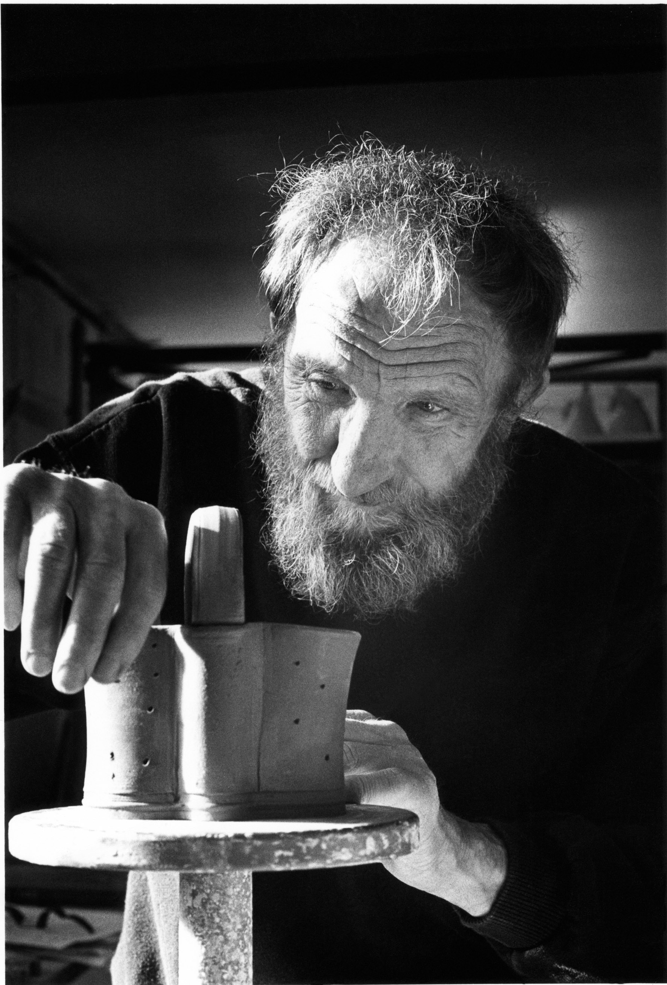

A rare opportunity to come and see the much admired work of one of our great post war potters, Michael (Mick) Casson. The exhibition returns to the big barn at Wobage - the Casson family home in Herefordshire, following a successful showing at the Ruthin Craft Centre in Denbighshire .The exhibition celebrates the launch of the beautifully illustrated biography - Michael Casson - written by Emanuel Cooper and Amanda Fielding, published by the Ruthin Craft Centre.
Emanuel writes, “Casson’s pots carry a range of messages about the aesthetic value of handmade objects but they also embody a set of ethical values derived from the Arts and Crafts movement. Such qualities are to do with integrity, with meaningful choice and the importance of humanistic values….”
Mick Casson's pots have an unfading integrity, the forms, most notably jugs are principally medieval European in feel; his 'baluster' and 'Puisaye' jugs allude to this aspect of his potting roots. “Function” wrote Mick “is the prime motivator for me as a vessel maker” he said that it “allows an aesthetic which is valid, important and meaningful in terms of its ability to express the whole range of our emotional and intellectual responses to form, colour, texture - all the classical ingredients that we have to mix in order to enjoy any visual art form”.
The more elaborately decorated cut paper-resist 'Swimmers' on large bowls and pedestal forms are, he would have said, simply about his love of swimming. These instinctively cut swimming figures express the care and connection he had with people. Mick was a giver of time, advice and enthusiasm, as both a friend and educator.
Other pots in the exhibition include jars, teapots, bread bins, bottles, often decorated with quick marks, a gesture to enhance form. He worked with the kiln, fire and salt, allowing each to take their vital part: Mick’s totally connected approach to pottery was integrated and holistic.
This long awaited exhibition of pots, since Mick's death in December 2003 will not disappoint the already enthused - while allowing fresh eyes a genuine insight into one mans homage to potting.
Fellow potter Jane Hamlyn speaks for many when she says “'Mick Casson possessed the greatest gift: he inspired people with confidence in themselves. He understood first-hand the exigencies of making a living as a potter so his advice was always down to earth and realistic -and often punctuated with a wicked wit! He once told me that the pots we make express what we are or what we would like to be. Mick's pots are intelligent and generous and life affirming”.
The exhibition runs alongside the Wobage Makers Gallery selling exhibition for Herefordshire Art week, featuring new work by 'Adopt a Potter' apprentice Sheila Herring.
For more information regarding the exhibition contact Ben Casson.
www.wobagecrafts.co.uk
www. workshops-at-wobage.co.uk
www.h-art.org.uk
www.adoptapotter.org.uk

